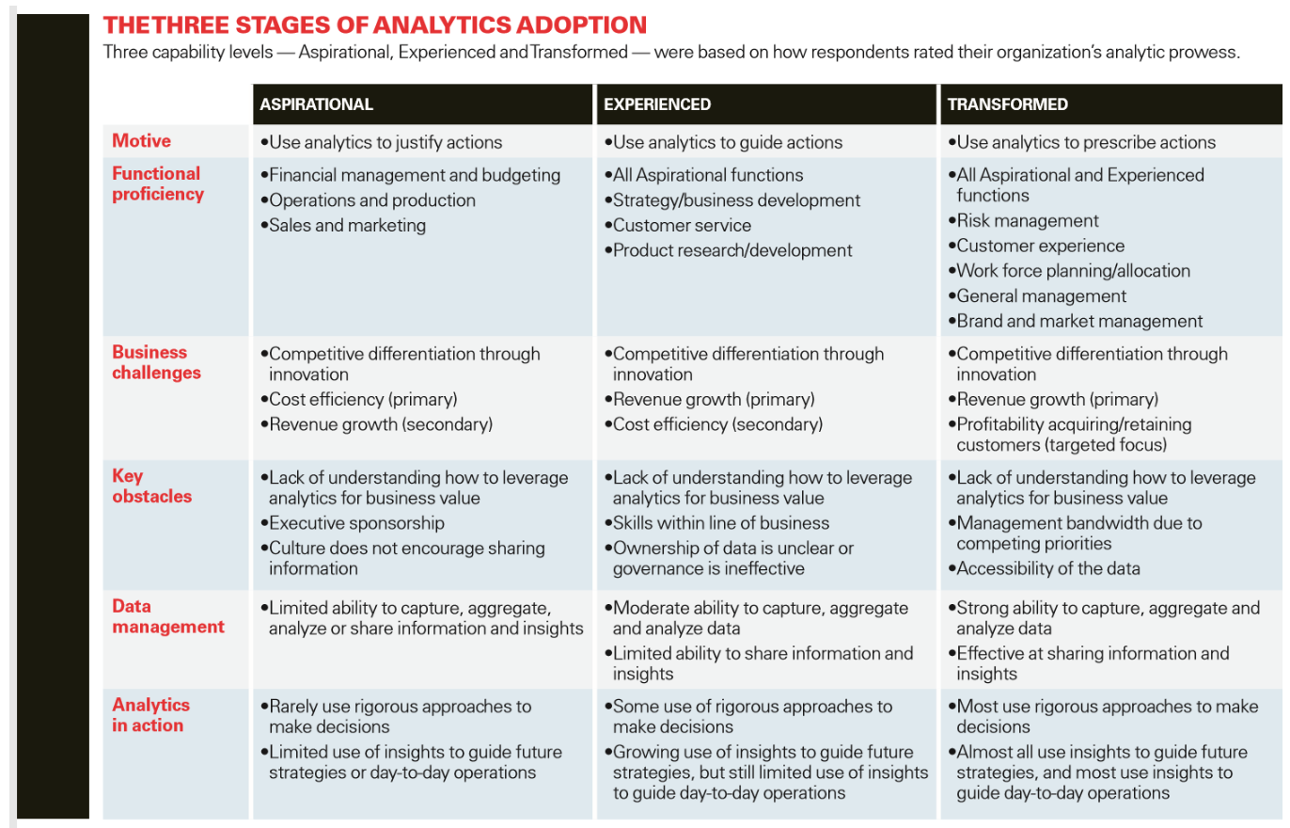

|  |  |  |  |
| --- | --- | --- | --- |
|  | Aspirational | Experienced | Transformed |
| Motive |  | x |  |
| Functional proficiency | x |  |  |
| Business challenges |  | x |  |
| Key obstacles |  |  | x |
| Data management | x |  |  |
| Analytics in action |  |  |  |

**Motive:** We think the motive of Mise en Place is Experienced because they guide their actions. An example they gave: In 2019, there is a law coming that changes the minimum wage of younger people, so that their minimum wage will be the same as people who are a bit older. Mise en Place coincidentally has a lot of young workers. This minimum wage change will impact the financial status a lot. With data, they can calculate the difference in their finances when this law has been implemented. Based on that difference, they can act accordingly to prevent the damage to their financial status when this law is implemented. In our eyes, this is seen as using data to guide their actions.

**Functional proficiency:** We think the functional proficiency of Mise en Place is on a Aspirational level. One of Mise en Place’s core skills is having a good physical relationship with their clients. To many of their clients, this is a nice thing to have. They deliberately don’t use data in this process, to maintain this relationship. They use their data to make predictions on their financial status, focusing on the internal costs. They do not place emphasis to use data for sales and marketing usage.

**Business challenges:** We think Mise en Place is on an experienced level here. The main goal of Mise en Place is revenue growth. In the interview, they stated that an essential possibility with big data is to assess their financial situation in a few months. To us, this is done with the revenue growth of the company in mind. They assess their situation in a few months, and based on that information, they can look for ways to optimize processes internally to grow their revenue.

**Key obstacles:** We think Mise en Place is on a transformed level here. We think their main obstacle right now is the accessibility of data. Our contact person stated that they are still relatively new to using data in their company, and only a few people are actually skilled enough to be able to do something with the data they have at the moment. An obstacle for them would be then accessibility of data, because there are not enough people working there that can do something with the data.

An example that the contact person gave: Our workers sometimes fill in the data themselves. Sometimes, when they lack information, for example, where the client lives, they fill in the location of Mise en Place. This is not useful in any means, because that client doesn’t live there.

**Data management:** We think Mise en Place is on an aspirational level here. They use Excel primarily for the processing of data, and only have a few people that have the skills to work with the data. Mise en place is still relatively new to analyzing data, and a growing at a steady rate when it comes to this topic.

**Analytics in action:** We think Mise en Place is on an experienced level here. They are growing in the usage of data for future strategies. They put a lot of emphasis on using data for future strategies, and they are growing in that aspect on a monthly basis. They are not that experienced yet in the usage of data for day-to-day strategies.